***Lyddie***

***Chapter 10 – “Oliver”***

The bell rang to wake the girls up at 4:30 A.M.  Lyddie got up and got dressed quickly.  She felt very hungry, but knew she would not get breakfast until 7:00 A.M so she would have to work for two hours first.



Lyddie met Diana outside of the factory doors and Diana told her that they would work the three looms together until Lyddie got the hang of it.

Within five minutes Lyddie's head was pounding from all of the loud noises and she had a horrible headache.  Soon, her feet were so swollen from standing she could barely walk and needed to untie her shoes.  The air in the factory was so dusty that Lyddie's eyes were burning.  With all of this happening, Lyddie was trying her best not to burst into tears.



After what seemed like an [eternity](http://bookbuilder.cast.org/view_glossary.php?book=110639&word=85786#curr)  it was finally time to eat breakfast.  However, even though Lyddie was excited she felt half the time she had was spent going up and down stairs and waiting in line.  Lyddie felt so rushed she did not enjoy her meal. Soon enough, it was time to go back to work.

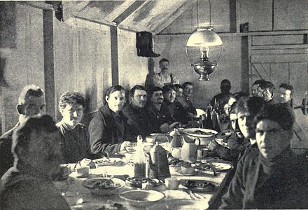

Hours later, it was finally time for dinner.  However, Lyddie was so [nauseous](http://bookbuilder.cast.org/view_glossary.php?book=110639&word=85788#curr) from her first full day of work at the factory she could barely eat or enjoy it.

Soon, Lyddie went back up to her room and was with her roommates.  One of her roommates, Betsy, suggested that tomorrow Lyddie wear her old boots so that her feet did not [blister](http://bookbuilder.cast.org/view_glossary.php?book=110639&word=85787#curr) or hurt her as much.  Lyddie agreed with Betsy and said tomorrow she would wear the boots Triphena gave to her.

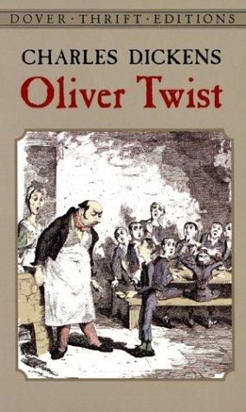

Finally, Lyddie decided she wanted to go to sleep.  As Lyddie was lying in bed Betsy kindly offered to read to her.  Lyddie didn't know what the book was but she soon realized it was about a poor boy named [Oliver Twist](http://bookbuilder.cast.org/view_glossary.php?book=110639&word=85789#curr) , who reminded her of Charlie.

Lyddie loved the story so much that she said to Betsy, "Don't stop reading the story, please".

Betsy read until it was time for lights out, but promised to continue reading Lyddie the story tomorrow.

As chapter 9 opens, [Lyddie](https://www.enotes.com/topics/lyddie?en_action=hh_answer_body_click&en_label=%2Fhomework-help%2Fgive-summary-chapters-9-10-lyddie-590485%23answer-749389&en_category=internal_campaign) arrives on the floor of the weaving room after having gone through her official first-day procedures for new hires. She is startled by how loud the room is; she can hardly hear the instructions the overseer gives her. Diana, a co-worker, jumps in to show her the ropes. At one point they are able to step away from the noisy machines and Diana asks Lyddie if she likes to read. Lyddie admits she's not good at reading, and Diana tells her she can visit her that night so Diana can help her read the regulations. That evening Lyddie's roommates give her a hard time for going to see Diana. They warn her that Diana is a "known radical," but Lyddie goes to see her anyway. She finds Diana to be kind and understanding; Diana even gives Lyddie paper and postage so Lyddie can write her mother and Charlie, letting them know she is in Lowell. When Lyddie returns to her room, her roommates grill her about what happened at Diana's and again warn her about Diana, calling her "devious."

In chapter 10, Lyddie completes her first full day on the floor, and she finds it difficult and exhausting. Her feet swell in her new boots, the air is thick with debris, and the noise is deafening. Diana helps her get through the day, but when she gets back to the boarding house, she is nearly too tired to eat her supper. When she crawls into bed early, Betsy offers to read to her aloud from her novel, Oliver Twist. Lyddie is fascinated by the tale of poor young Oliver, who gets hauled before "a sort of agent" simply for asking for more food. When Betsy tries to explain about the author of the book, Lyddie says, "Don't stop reading, please." She is completely engrossed in the story.

A true "Lowell Factory Girl," [Lyddie](https://www.enotes.com/topics/lyddie?en_action=hh_answer_body_click&en_label=%2Fhomework-help%2Fwhat-summary-chapter-10-10403%23answer-669872&en_category=internal_campaign) spends her first day finally working in the dismal textile factory.  Lyddie's day begins even before the sun comes up.  It is a horrid, thirteen-hour day.  Even the time for meals is cut short during the two short breaks to nourish herself.  Breathing in the small cloth fibers into her lungs and dodging the dangerous "shuttles" as they fly back and forth between the weaving looms becomes commonplace for Lyddie as she tries desperately to adjust to the horrible factory conditions, as even the air is "laden with ... debris."  A further problem is the noise in the factory, the looms and shuttles are so very loud that they eventually can damage a young woman's hearing.  After growing up in a small cabin in Vermont and being proud enough to refuse all charity donations, this adjustment to the bad conditions in the Lowell factories is hard for Lyddie.  After this first day of work among the looms, meeting some of her coworkers and her overseer, Lyddie returns to her bed completely exhausted. Her feet are swollen and her head is aching beyond belief.  At this point, Lyddie's only desire is one thing:  sleep.

The character of Betsy now becomes a very important character in the story.  The author, [Katherine Paterson](https://www.enotes.com/topics/katherine-paterson?en_action=hh_answer_body_click&en_label=%2Fhomework-help%2Fwhat-summary-chapter-10-10403%23answer-669872&en_category=internal_campaign), uses Betsy to introduce the importance of reading novels to improve one's quality of life.  After this first day working in the Lowell factories, Lyddie's roommate, Betsy, simply asks if she can read some of Charles Dickens' Oliver Twist to Lyddie as she tries to sleep.  Betsy's reading of Dickens has the opposite effect that Lyddie originally expects.  In fact, Lyddie is so engrossed in the storyline and factory conditions in England within the novel of Oliver Twist that Lyddie tries desperately to keep her eyes open so that she can listen to more of Dickens' words.  Not one to put things lightly, Lyddie exclaims that, instead of being "silly," Charles Dickens' novel truly "was life or death."

It is this concept and this first listening to Charles Dickens' novel that inspires Lyddie to learn to read on her own.  It is stories like Oliver Twist that give Lyddie a reason to keep on living, even in the horrible conditions to which she is subjected.  In Oliver, Lyddie finds a character whose life rivals her own in regards to misery.  Lyddie's heart goes out to the orphaned Oliver who is threatened with death when he "dares" to ask for more to eat and is forced, also, to work under horrible conditions during the England of the Industrial Revolution.  Further, the character of Oliver reminds Lyddie of her own little Charlie and draws her heart further into the story.  Both Lyddie and Charlie (even back home in Vermont) had many days when neither of them had enough to eat.  With these thoughts in Lyddie's head, she finally falls asleep and prepares to meet yet another day in the grueling factories at Lowell.

Chapter 10 recounts Lyddie's first full day working in the factory.  The routine is brutal, beginning before dawn and lasting thirteen hours, with only two short breaks for meals in between.  The noise in the factory is oppressive, and the air  "laden with moisture and debris".  Lyddie stumbles home at the end of the day, and with swollen feet and aching head, goes directly to bed.  One of the girls offers to read aloud to her, and Lyddie is quickly absorbed in the story, Dickens' Oliver Twist.  The tale of the hungry orphan who may be hung for daring to ask for more food strikes a chord with her, reminding her of her brother Charlie and the times when they too didn't even have enough to eat.